**List Exercise:** What is the output for numbers 1 and 2, and what is the codes for numbers 3 and 4?

1. [i for i in “citcs”]

**Output:** ['c', 'i', 't', 'c', 's']

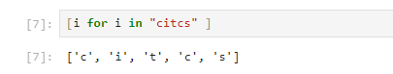

2. [i for i in range(1, 11)]

**Output:** [1, 2, 3, 4, 5, 6, 7, 8, 9, 10]

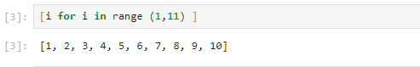

3. [2, 4, 6, 8, 10]

**Code:** [i*2 for i in range(1, 6)]

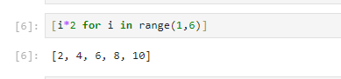

4. [1, 3, 5, 7, 9]

**Code:** [i*2-1 for i in range(1, 6)]

